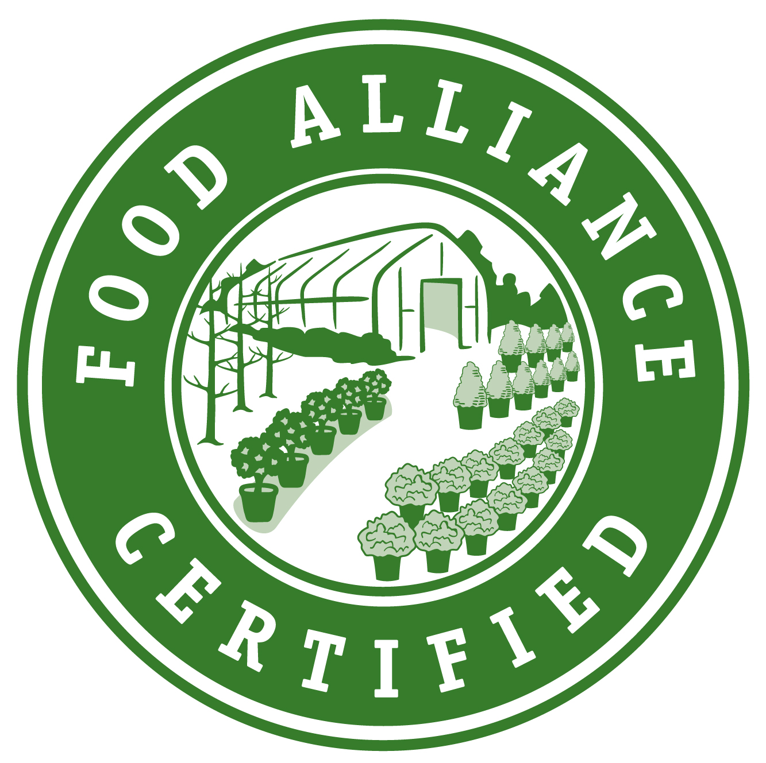
Nursery Production Wildlife Habitat and Biodiversity Conservation Evaluation Tool
This evaluation tool is to be used in conjunction with relevant Nursery Production Field, Container, and/or Greenhouse Production Evaluation Tools.

Operation Name:
Address:
Evaluation Date:
Evaluator/Inspector:

Instructions for Use

- Each standard area is scored according to Food Alliance evaluation criteria. Points are given for performance of each evaluation criteria as measured against the indicators in Levels 1 through 4. Points are only earned for the highest Level achieved.

- Scoring partial points is allowed. Example: Half of the operation is in a 4-year crop rotation, a Level 3 practice. As a result, you may score 2.5 points, or half the increase between Level 2 and Level 3.

- No points are earned for a criterion that is not applicable (N/A) to the operation or region. These points are subtracted from the total as explained on the score sheet. This ensures all operations are scored fairly, based on the actual facilities present and practices in use. A full explanation for any N/A is required.

- For producer/managers reviewing this evaluation tool: This is only a guideline for your use and does not guarantee acceptance of your application.

- Inspectors should make notes on each criterion describing how they arrived at decisions, including means used to verify all specific producer/manager claims. These notes provide important background, which will be carefully considered in the final certification decision. Please make note of any criteria or indicators that were not applicable and the reason. Also include any Best Management Practices (BMPs) implemented by the producer/ manager that are not listed in this inspection tool.

- Inspectors may request records or other materials to document any claims made by producer/manager.

Contents

Nursery Production Wildlife Habitat and Biodiversity Conservation 1
Evaluation Tool 1
Instructions for Use 1
Contents 2
Continuing Education for Biodiversity Conservation 3
Biodiversity Plan 4
Reducing On-Site Threats to Wildlife 4
Biodiversity Conservation in Plant Production Areas and Cropped/Grazed Areas 6
Biodiversity Conservation in Natural or Unused Areas 8
Invasive Species Prevention and Management 10
Linking Individual Wildlife Habitat Conservation Activities Together 11
Scorecard 12

These criteria describe general approaches to biodiversity management. Practices listed are intended to serve as indicators of management approach, intent, and desired outcomes. Conservation activities will be more obvious when on site. Provide notation of viewed activities.

Continuing Education for Biodiversity Conservation
Level 1: Manager demonstrates little or no knowledge about wildlife habitat or threatened/ endangered species conservation. Current operation reflects this knowledge gap, with no special planning or action considered to prevent agricultural activities from interfering with natural areas (if present).

Level 2: Manager relies on general interest publications (newspapers and general newsletters, etc.) to learn about wildlife and habitat issues, natural pest control, establishment of insectary plants, predatory bird nesting sites, etc. Manager demonstrates a basic understanding of the issue area. One of the following applies. Check applicable:
- There are no natural areas on the operation.
- Natural areas exist on the operation and actions are limited to preventing agricultural activities from interfering with natural areas.

Level 3: Manager uses technical, subject matter-specific information sources, or participates in seminars for habitat management, identification of habitat types or native vegetation, fish, or wildlife management, etc. When natural areas exist on the operation, manager can discuss wildlife and habitat issues and communicates knowledge of the following. Check all that apply:
- General habitat management
- Native plants
- Native animals
- Invasive or exotic plants and animal
- Sensitive, priority habitat
- Endangered or at-risk species
- Migratory species
- Riparian habitat
- Aquatic ecosystems
- Other (please specify):

Level 4: Manager participates (or has participated in the last 5 years) in on-site testing of new wildlife habitat conservation strategies or concepts to evaluate their performance.

Score:

Verification methods and notes:

Biodiversity Plan
Level 1: Manager has not developed a Biodiversity Plan for the operation.

Level 2: One of the following applies:
- Manager has completed Section I of the Food Alliance Biodiversity Plan, mapping, and describing existing biodiversity features and problem areas.
- Manager has a document containing similar information such as a National Resource Conservation Service (NRCS) Conservation Plan.

Level 3: Manager has completed sections I, II A, and II B of the Food Alliance Biodiversity Plan, and 1 of the following applies:
- Using Sections III and IV of the Food Alliance Biodiversity Plan, manager has identified at least 2 biodiversity threats, at least 2 biodiversity opportunities, and management actions to address them.
- Manager has a similar document in place, such as an NRCS Conservation Plan, that addresses the same issues as the Food Alliance Biodiversity Plan.

Level 4: As per Level 3, and 1 of the following applies:
- Manager has completed all of sections II, III, and IV of the Food Alliance Biodiversity Plan and can describe how the operation’s plan is used to meet other Food Alliance biodiversity criteria.
- Manager has a similar document in place, such as an NRCS Conservation Plan, that addresses the same issues as the Food Alliance Biodiversity Plan, and can describe how the operation’s plan is used to meet other Food Alliance biodiversity criteria

Score:

Verification methods and notes:

Reducing On-Site Threats to Wildlife
Level 1: Manager communicates little or no knowledge about wildlife on/around the operation, and no steps are taken to reduce on-operation’s threats to wildlife.

Level 2: Manager can identify on-site threats to wildlife but has not taken significant steps to reduce threats.

Level 3: Manager has identified on-site threats to wildlife and biodiversity in operation’s plan, and has completed at least 1 identified action to minimize threats to biodiversity. Manager can describe how the action addresses the threat. In addition, 1 or more of the following apply.
Check all applicable:
- If water-holding facilities (tanks, troughs, etc.) are present, they provide safe access and escape for wildlife and are free of hazards for aerial wildlife.
- Management ensures that water resources on the operation are protected from contamination by activities of the operation.
- Fencing is constructed around individual fields rather than surrounding the entire operation.
- Grain harvest is delayed (as appropriate) to provide cover for hatching of ground nesting birds.
- Fences are constructed with considerations for wildlife species and their movements. For example, fences may use smooth wire rather than barbed or woven wire, if this meets the operation’s needs, or fences may be constructed to allow smaller wildlife to go under the barrier. Pasture fences may also be designed to allow large wildlife to pass through by spacing the top 2 wires at least 12 inches apart.
- Grazing routine takes into account habitat needs, including reproduction and migration, of priority species and other wildlife. Time intervals between grazing may be increased to accommodate wildlife species.
- In pastures, hay fields, or natural areas, all grasses are left unmowed during migration or reproductive times. Spring mowing is delayed as needed to allow ground-nesting species to nest, reproduce, and grow.
- Vehicle traffic and activities around natural areas are limited during migration and reproductive times, and/or when wildlife is present, or traffic is completely restricted from natural areas.
- Manager limits other disturbances to wildlife, especially during sensitive stages of species’ life cycles (reproductive and rearing) and migratory activity.
- Mowing equipment has a flushing bar installed to flush birds and other wildlife and prevent mortality.
- Manager uses benign practices whenever possible to protect crops from wildlife damage.
- Priority species are not harmed, including keystone species such as prairie dogs and beavers that provide habitat for wildlife.
- Where practiced, ditch cleaning is done with proper precautions (e.g., timing) for aquatic habitat, fish, and water quality.
- Other (as specified in plan):

Level 4: As per Level 3, and manager has identified opportunities to reduce on-site threats to wildlife in the Food Alliance Biodiversity Plan or other plan. A total of 3 or more practices from Level 3 have been implemented.

Score:

Verification methods and notes:

Biodiversity Conservation in Plant Production Areas and Cropped/Grazed Areas
Level 1: The operation has made no apparent improvements related to biodiversity conservation in plant production areas or cropped/grazed areas. Hedges, live trees, dead snags, and other natural habitat elements have been removed without first exhausting other alternatives. Manager has not considered options for increasing in-field diversity.

Level 2: Manager has identified opportunities for biodiversity conservation in plant production areas and cropped/grazed areas but has not made improvements.

Level 3: Manager has identified opportunities to improve biodiversity in plant production areas and cropped/grazed areas and has begun to make improvements. At least 1 high-impact improvement and at least 2 low-impact improvements have been implemented, where applicable. Check all that apply:

Low impact improvements:
      - Pollinator and natural enemy insectary plants are grown in and around fields to increase organic matter and provide cover and habitat for beneficial insects and other wildlife.
      - Structures are created to meet specific needs of native species, including beneficials. For example, bird perches are created on field edges to encourage predatory birds; owl or bat boxes are constructed to establish predator populations; and/or wooden blocks or bundles of stems or straws support native tunnel-nesting bees.
      - Structures such as barns and sheds are managed to provide habitat for native birds and bats.
      - Native plants, especially pollinator-friendly plantings, are used to landscape around buildings.
      - Growing a variety of crops in annual systems or intercropping in perennial systems brings diversity to the operation and benefits soil microorganisms.
      - Grazed areas are well-managed and overgrazing is prevented. Frequency, intensity, and timing of livestock grazing are managed to minimize negative impacts to soil, vegetation, and ecosystem health.
      - Trees, especially large live or dead trees, are left in place in and around fields for predatory birds and other wildlife.
      - Beetle banks are established.
      - Ditch clearing is alternated from side to side each year.
      - Crop residue/stubble is left standing to provide cover or food for wildlife.
      - A small portion of the crop is left unharvested for wildlife.
      - Other (please specify):

High impact improvements
      - Fields are left fallow for a year or more to provide wildlife habitat.
      - Fallow fields, pastures, or crop stubble are flooded, if appropriate, to provide habitat for waterfowl and shorebirds.
      - Fallow fields are left with plant cover to provide food, water, and/or cover. This includes cover crops, or crop residue left on soil surface. Cover crops, especially winter covers, can displace invasive weeds, increase soil organic matter, provide temporary wildlife habitat, and control erosion control.
      - Field rotations include a fallow period specifically designed for wildlife habitat
      - Trampled or eroded areas are restored with native perennial grasses and forbs for the benefit of wildlife as well as livestock.
      - Multiple grasses and forbs comprise the pastures and resting fields.
      - Grazing areas are populated by multiple species of grasses and forbs.
      - Manager makes arrangements to supply water as needed to water holding areas for use by wildlife, where appropriate.
      - Grazing areas or agro-forestry enterprises are established to benefit wildlife habitat as well as plant production areas and cropped/grazed areas.
      - Pastures or agro forestry enterprises are established for the dual benefit of plant production and wildlife habitat.
      - Other (please specify):

Level 4: As per Level 3, and manager has identified opportunities to improve biodiversity in plant production areas and cropped/grazed areas in the Biodiversity Plan. A total of at least 2 high-impact improvements from Level 3, and a total of at least 3 low-impact improvements from Level 3 have been implemented Check all that apply:

Low impact improvements:
      - Pollinator and natural enemy insectary plants are grown in and around fields to increase organic matter and provide cover and habitat for beneficial insects and other wildlife.
      - Structures are created to meet specific needs of native species, including beneficials. For example, bird perches are created on field edges to encourage predatory birds; owl or bat boxes are constructed to establish predator populations; and/or wooden blocks or bundles of stems or straws support native tunnel-nesting bees.
      - Structures such as barns and sheds are managed to provide habitat for native birds and bats.
      - Native plants, especially pollinator-friendly plantings, are used to landscape around buildings.
      - Growing a variety of crops in annual systems or intercropping in perennial systems brings diversity to the operation and benefits soil microorganisms.
      - Grazed areas are well-managed and overgrazing is prevented. Frequency, intensity, and timing of livestock grazing are managed to minimize negative impacts to soil, vegetation, and ecosystem health.
      - Trees, especially large live or dead trees, are left in place in and around fields for predatory birds and other wildlife.
      - Beetle banks are established.
      - Ditch clearing is alternated from side to side each year.
      - Crop residue/stubble is left standing to provide cover or food for wildlife.
      - A small portion of the crop is left unharvested for wildlife.
      - Other (please specify):

High impact improvements
      - Fields are left fallow for a year or more to provide wildlife habitat.
      - Fallow fields, pastures, or crop stubble are flooded, if appropriate, to provide habitat for waterfowl and shorebirds.
      - Fallow fields are left with plant cover to provide food, water, and/or cover. This includes cover crops, or crop residue left on soil surface. Cover crops, especially winter covers, can displace invasive weeds, increase soil organic matter, provide temporary wildlife habitat, and control erosion control.
      - Field rotations include a fallow period specifically designed for wildlife habitat
      - Trampled or eroded areas are restored with native perennial grasses and forbs for the benefit of wildlife as well as livestock.
      - Multiple grasses and forbs comprise the pastures and resting fields.
      - Grazing areas are populated by multiple species of grasses and forbs.
      - Manager makes arrangements to supply water as needed to water holding areas for use by wildlife, where appropriate.
      - Grazing areas or agro-forestry enterprises are established to benefit wildlife habitat as well as plant production areas and cropped/grazed areas.
      - Pastures or agro forestry enterprises are established for the dual benefit of plant production and wildlife habitat.
      - Other (please specify):

Score:

Verification methods and notes:

Biodiversity Conservation in Natural or Unused Areas
□ N/A: No natural areas exist on the operation.

Level 1: The operation has unused areas that are not used for plant production or other activities of the operation, but these are kept bare or are dominated by invasive species. Threats to wildlife and opportunities for biodiversity conservation are not considered in managing unused areas.

Level 2: Unused areas are managed to avoid introduction and establishment of invasive species. Some areas, including fencerows, hedgerows, and center-pivot corners, are left uncropped and include perennial ground cover.

Level 3: Manager has identified opportunities to improve biodiversity in natural or unused areas. Native vegetation is established in unused areas (e.g., fencerows, windbreaks, field margins, center-pivot corners, riparian buffers) or natural areas are left intact and not converted to production. At least 2 improvements have been implemented. Check all that apply:
- Plantings of native species in unused areas include a diversity of grasses and forbs, including flowering species that benefit native pollinators.
- Landowner participates in a Farm Bill incentive program, including CRP, WHIP, or EQIP. [Credit is given only if these areas are managed specifically for wildlife habitat].
- Areas of remnant or high-priority habitat (e.g., native prairie, prairie pothole, or other wetland) are left intact and not converted to production.
- Natural processes such as fire and flood are allowed to operate in natural areas when possible.
- Riparian buffers, windbreaks, and other larger set-aside areas where trees and shrubs are appropriate maintain good canopy cover (>50%) of mixed multi-aged, native species. Newly established plantings have a ground cover including a mix of appropriate grasses and shrubs with a second-story of cover and habitat, especially along stretches of streams or rivers in need of bank stabilization.
- A conservation easement or other long-term agreement protects the conservation values on the land.
- Where possible, areas of native vegetation on-site are linked with surrounding natural areas to provide habitat connectivity. Cooperating with surrounding landowners can help create a larger landscape that allows for movement of wildlife.
- Areas of native vegetation are increased in size over time to benefit a greater number and diversity of species.
- Natural areas are managed to benefit the specific needs of threatened or endangered species that occur locally.
- Other (please specify):

Level 4: Opportunities to improve biodiversity in natural or unused areas are identified in the Biodiversity Plan. Manager consults with experts to ensure that plantings are site-appropriate given the context of the larger ecosystem (e.g., shrubs and trees are not established on a grassland site). A total of 3 or more improvements from Level 3 have been implemented
Check all that apply:
- Plantings of native species in unused areas include a diversity of grasses and forbs, including flowering species that benefit native pollinators.
- Landowner participates in a Farm Bill incentive program, including CRP, WHIP, or EQIP. [Credit is given only if these areas are managed specifically for wildlife habitat].
- Areas of remnant or high-priority habitat (e.g., native prairie, prairie pothole, or other wetland) are left intact and not converted to production.
- Natural processes such as fire and flood are allowed to operate in natural areas when possible.
- Riparian buffers, windbreaks, and other larger set-aside areas where trees and shrubs are appropriate maintain good canopy cover (>50%) of mixed multi-aged, native species. Newly established plantings have a ground cover including a mix of appropriate grasses and shrubs with a second-story of cover and habitat, especially along stretches of streams or rivers in need of bank stabilization.
- A conservation easement or other long-term agreement protects the conservation values on the land.
- Where possible, areas of native vegetation on-site are linked with surrounding natural areas to provide habitat connectivity. Cooperating with surrounding landowners can help create a larger landscape that allows for movement of wildlife.
- Areas of native vegetation are increased in size over time to benefit a greater number and diversity of species.
- Natural areas are managed to benefit the specific needs of threatened or endangered species that occur locally.
- Other (please specify):

Score:

Verification methods and notes:

Invasive Species Prevention and Management
Level 1: Present or potential invasive species are not identified in the Biodiversity Plan. Manager neither prevents establishment of invasive species nor systematically controls invasive species. Manager is not informed about the issue. Check all that apply:
- Manager deals with problems in plant production areas and cropped/grazed areas stemming from invasive species as they are encountered and/or as time permits.
- Manager has no plan or systematic inventory of invasive species problems.
- Manager communicates no knowledge of invasive species or how to identify them.
- Operation’s records do not refer to invasive species and are not used in reduction of invasive species problems.
- Operation currently produces invasive species.
- Other (please specify):

Level 2: Present or potential invasive species are identified in the Biodiversity Plan, and manager can identify or describe most common species. Check all that apply:
- Control of invasive species involves limited prevention strategies.
- Manager performs rudimentary planning for invasive species control with some inventory of existing problems.
- Inventory of invasive species problems extend beyond the plant production area, cropped or grazed areas, and into habitat areas.
- Manager communicates some knowledge of species life history and vulnerabilities in order to increase treatment effectiveness.
- Other (please specify):

Level 3: As per Level 2, and actively prevents introduction and spread of invasive species by implementing policy/protocols in Biodiversity Plan. One or more of the following apply:
- Manager establishes a policy or protocol designed to prevent establishment, not just control, of invasive species as problems arise.
- Where seeds and composts are purchased, manager uses only certified seed and composts to prevent weed seeds from coming onto the operation.
- Steps are taken to eradicate invasive species in natural areas while not harming the habitat and populations of natural species.
- Manager communicates solid knowledge base of invasive species in the area and demonstrates the ability to identify the species with some life history knowledge.
- Manager keeps control records to improve control program.
- Manager seeks additional knowledge to assist with control program effectiveness.
- Other (please specify):

Level 4: As per Level 3, and a total of 3 or more from Level 3 apply. Manager has an advanced understanding of Integrated Pest Management (IPM) principles and application, including bio-control, and implements policy/protocols in the Biodiversity Plan to prevent the introduction and spread of invasive species. Check all that apply:
- Manager has systematic inventory and stated thresholds that trigger control action.
- Invasive species are a high priority in overall operation as reflected in the operation’s plans and records.
- Manager has advanced knowledge of life cycles and control is performed at most effective time.
- With noxious weeds, manager has planned revegetation with desirable plants to gain control of site.
- Manager uses predators of invasive species and other bio-control methods.
- Manager keeps comprehensive records and evaluates program each year for effectiveness.
- Land clearly shows results of this Comprehensive Invasive Species Management Program.
- Manager works with state/federal agencies (e.g., Dept. of Natural Resources, Dept of Agriculture) to develop and implement control plans.
- Manager discusses problems with neighbors to increase effectiveness of the control effort.
- Manager actively tries to coordinate with neighbors in control efforts that have an impact on the wider general area.
- Other (please specify):

Score:

Verification methods and notes:

Linking Individual Wildlife Habitat Conservation Activities Together
- Note: Government projects are included in this criterion.

Level 1: Manager is not involved with other landowners or regional/state/federal agencies to link individual on-site actions to larger landscape activities.

Level 2: Manager participates in watershed councils, soil and water districts, or other landscape activities promoted by regional/state/federal agencies, industry organizations, non-profits, or similar groups.

Level 3: At least 1 of the following applies:
- Manager has made on-site habitat improvements in concert with nearby landowners.
- Manager has made on-site habitat improvements on their own to create large and/or connected patches of habitat.
- Manager has participated in, or invested in, off-site habitat improvements.

Level 4: Manager has made on-site habitat improvements or participated in, or invested in, off-site habitat improvements as a part of a regional plan that includes other landowners. Manager has contributed to, or participated in, the implementation of the following. Check all that apply:
- Watershed council plan
- Eco-regional plan (such as those created by groups like The Nature Conservancy, etc.)
- Coordinated resource management plans
- Soil and water district plans
- Regional or statewide habitat/Biodiversity Plans
- Other (please specify):

Score:

Verification methods and notes:

Scorecard

Scorecard for wildlife habitat and biodiversity conservation
CRITERIA | SCORE/LEVEL
Continuing education for biodiversity conservation
Biodiversity plan
Reducing on-site threats to wildlife
Biodiversity conservation in plant production areas and cropped/grazed areas
Biodiversity conservation in natural or unused areas
Invasive species prevention and management
Linking individual wildlife habitat conservation activities together
(1) TOTAL POINTS EARNED =
Total Points Available | 28
- Minus Total Points Not Applicable
(2) TOTAL APPLICABLE POINTS
(3) AVERAGE PERCENTAGE SCORE = [(1) / (2)] * 100 | %

